|  |  |
| --- | --- |
| Nama | : La Ode Muhammad Gazali |
| NIM | : 222212696 |
| Kelas | : 2KS2 |

**Modul 5 Praktikum Sturktur Data**

1. Cobalah untuk memod**if**ikasi potongan program pada pembuatan simpul awal, insert kanan, dan delete kanan sehingga pointer tail dideklarasikan dan selalu diperbaharui isinya saat penambahan dan penghapusan simpul dari kanan.

Program :

**#include<stdio.h>**

**#include<stdlib.h>**

**struct** node{

**int** value;

**struct** node *next;

**struct** node *prev;

};

**typedef** **struct** node *ptrnode;

ptrnode createNode(**int** nilai){

ptrnode p;

p = (ptrnode)malloc(**sizeof**(**struct** node));

p->value = nilai;

p->next = NULL;

p->prev = NULL;

**return** p;

}

ptrnode insert_tail(ptrnode head, ptrnode *tail, **int** nilai) {

ptrnode new_node = createNode(nilai);

new_node->next = NULL;

**if** (head == NULL) {

new_node->prev = NULL;

head = new_node;

*tail = new_node;

// Perbarui tail saat memasukkan elemen pertama

} **else** {

new_node->prev = *tail;

(*tail)->next = new_node;

*tail = new_node;

}

**return** head;

}

ptrnode remove_last(ptrnode head, ptrnode *tail) {

**if** (head == NULL) {

**printf**("Daftar kosong, tidak ada yang dapat dihapus\n");

**return** head;

}

**if** (*tail == head) {

free(head);

*tail = NULL;

**return** NULL;

}

ptrnode temp = *tail;

*tail = (*tail)->prev;

(*tail)->next = NULL;

free(temp);

**return** head;

}

ptrnode tampilnilai(ptrnode head) {

ptrnode current = head;

**int** i=1;

**while** (current != NULL) {

**printf**("Node ke-%d : %d",i, current->value);

current = current->next;

i++;

**printf**("\n");

}

**printf**("\n");

**return** head;

}

**int** main(){

ptrnode head = NULL;

ptrnode tail = NULL;

head=insert_tail(head, &tail, 1);

head=insert_tail(head, &tail, 2);

head=insert_tail(head, &tail, 3);

**printf**("Daftar awal:\n");

tampilnilai(head);

insert_tail(head,&tail, 8);

**printf**("Daftar setelah insert tail:\n");

tampilnilai(head);

head = remove_last(head, &tail);

**printf**("Daftar setelah remove:\n");

tampilnilai(head);

**return** 0;

}

Output:

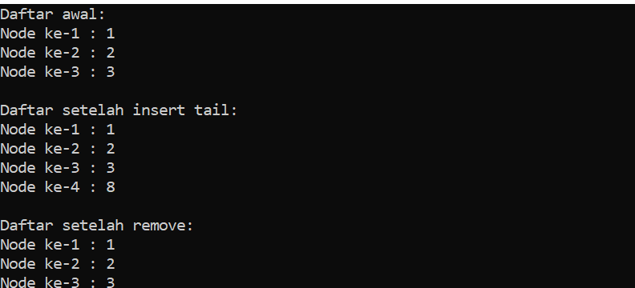

1. Buat sebuah program untuk menampilkan output di bawah ini menggunakan double linked list!

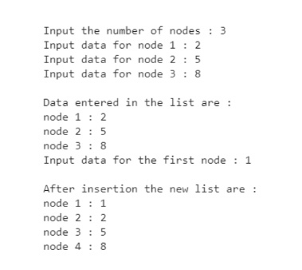

Program :

**#include<stdio.h>**

**#include<stdlib.h>**

**struct** node{

**int** data;

**struct** node *next;

**struct** node *prev;

};

**typedef** **struct** node* mynode;

mynode createNode(**int** nilai){

mynode temp;

temp = (mynode)malloc(**sizeof**(**struct** node));;

temp->data = nilai;

temp->next = NULL;

temp->prev = NULL;

}

**void** insert_head(mynode* head, **int** data) {

mynode newNode = createNode(data);

**if** (*head == NULL) {

*head = newNode;

} **else** {

newNode->next = *head;

(*head)->prev = newNode;

*head = newNode;

}

}

mynode insert_tail(mynode head, mynode *tail, **int** data) {

mynode new_node = createNode(data);

new_node->next = NULL;

**if** (head == NULL) {

new_node->prev = NULL;

head = new_node;

*tail = new_node;

// Perbarui tail saat memasukkan elemen pertama

} **else** {

new_node->prev = *tail;

(*tail)->next = new_node;

*tail = new_node;

}

**return** head;

}

mynode tampilnilai(mynode head) {

mynode current = head;

**int** i=1;

**while** (current != NULL) {

**printf**("Node ke-%d : %d",i, current->data);

current = current->next;

i++;

**printf**("\n");

}

**printf**("\n");

**return** head;

}

**int** main(){

**int** data,n;

mynode head = NULL;

mynode tail = NULL;

**printf**("Masukan jumlah data : ");**scanf**("%d",&n);

**for** (**int** i = 0; i < n; i++) {

**printf**("Masukkan data node ke-%d = ", i + 1);

**scanf**("%d", &data);

head = insert_tail(head, &tail, data);

}

**printf**("Daftar awal:\n");

tampilnilai(head);

**printf**("Masukan data untuk first node : ");

**scanf**("%d", &data);

insert_head(&head, data);

**printf**("Daftar setelah insert head:\n");

tampilnilai(head);

**return** 0;

}

Output:

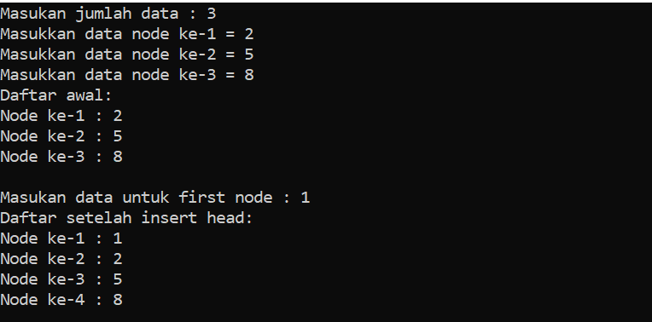

1. Bagaimana untuk membalik nilai-nilai dalam double linked list (tail ke head)?

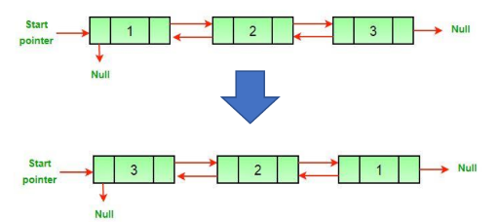

Program:

**#include<stdio.h>**

**#include<stdlib.h>**

**struct** node{

**int** data;

**struct** node *next;

**struct** node *prev;

};

**typedef** **struct** node* mynode;

mynode createNode(**int** nilai){

mynode temp;

temp = (mynode)malloc(**sizeof**(**struct** node));;

temp->data = nilai;

temp->next = NULL;

temp->prev = NULL;

}

**void** insert_head(mynode* head, **int** data) {

mynode newNode = createNode(data);

**if** (*head == NULL) {

*head = newNode;

} **else** {

newNode->next = *head;

(*head)->prev = newNode;

*head = newNode;

}

}

**void** membalik_nilai(mynode* head) {

mynode current = NULL;

mynode temp = NULL;

**while** (*head != NULL) {

temp = (*head)->prev;

(*head)->prev = (*head)->next;

(*head)->next = temp;

current = *head;

*head = (*head)->prev;

}

**if** (current != NULL) {

*head = current;

}

}

**void** tampilnilai(mynode head) {

mynode current = head;

**while** (current != NULL) {

**printf**("%d", current->data);

current = current->next;

**if** (current != NULL)

**printf**(" <=> ");

}

**printf**("\n");

}

**int** main(){

**int** data,n;

char pilih;

mynode head = NULL;

mynode tail = NULL;

insert_head(&head, 3);

insert_head(&head, 2);

insert_head(&head, 1);

**printf**("Daftar awal:\n");

tampilnilai(head);

membalik_nilai(&head);

**printf**("Daftar setelah membaik nilai:\n");

tampilnilai(head);

**return** 0;

}

Output:

